Reviewers:

Christopher Branch: How will it be monetized, what will it sound like, and what will the art style look like. (Art style, Sounds and Monetization added at bottom)  
Tyler Makrsuh in red

1. Game concept: The game would be a 1st or 3rd person hack and slash. Gameplay would be more grounded and simpler than games like Metal Gear Rising Revengence or Devil May Cry, (That would be the dream to have gameplay like that), more like Warhammer 40k Darktide or Chivalry. It will be more medieval fantasy themed because I already made a forest with magical floating candles. Weapons will be swords and spears, maybe guns if I can. i would like an option to quick switch between first and third person for guns to make it easer to shoot ie arma 3 ads mecanic. I guess it would depend on which perspective I decide on, If 1st person then shooting would be like other FPS games, if 3rd person then a there would most likely be a lock on mechanic.   
   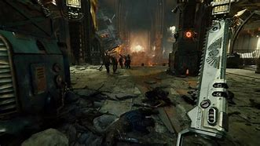 Darktide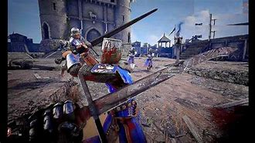Chivalry  
   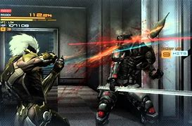Revengence  
   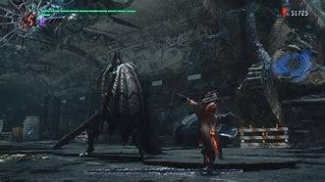DMC
2. Game loop: Making your way through the terrain while defeating enemies. If possible, a mixture of melee combat and gunplay. As with most Hack and slash games a combo counter.
3. Story: You’re living in a cabin in the middle of the woods when you are threatened and must make your way to the top of the mountain to face the final boss.
4. Genre: Medieval fantasy with guns if I can.
5. Game type: Hack and slash
6. User interface: Health bar in the top left corner, current weapon selected in the bottom corner. Be able to quickly swap weapons in combos. Similar UI is ther inventory items health potions exet. There would not need to be an openable inventory like a survival game, I would I add some pick ups in the field  
   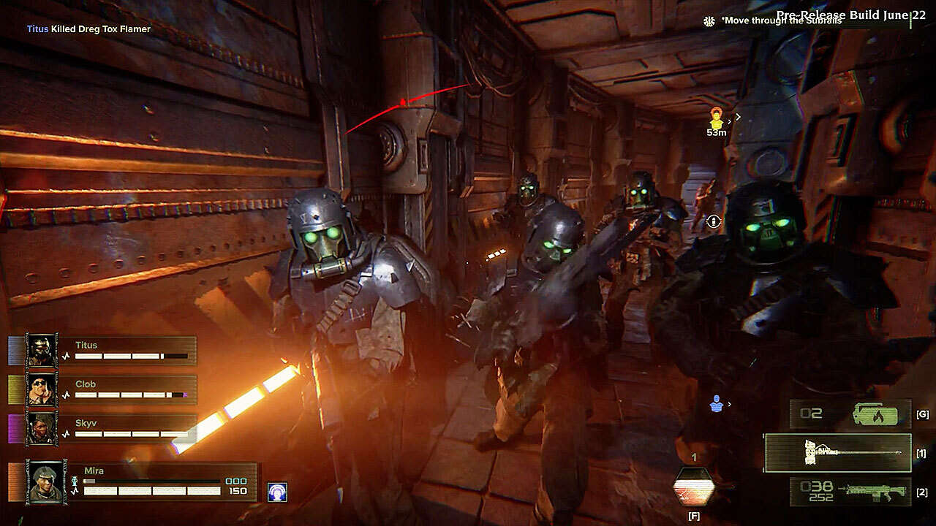
7. Platform: PC, Xbox, PlayStation
8. Controls: movement: WASD, Jump: spacebar, normal attack: left click, Heavy attack: right click, Weapon swap: mouse wheel or number keys or Q and E
9. Similar Games: Warhammer 40k Darktide/Warhammer Vermintide 2, some mechanics from Metal Gear Rising Revengence or Devil May Cry like a combo meter would be cool if I can.  
   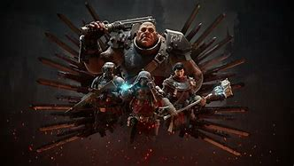  
   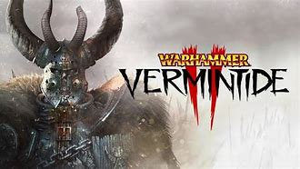
10. Art style: Simpler style of Chivalry, more cartoony medieval and no blood
11. Audio: clashing metal against metal and clanking of armor.
12. Monetization: Most likely this will be a time purchase for the game, If possible a DLC, new area and weapons.